What to wear web app - concept

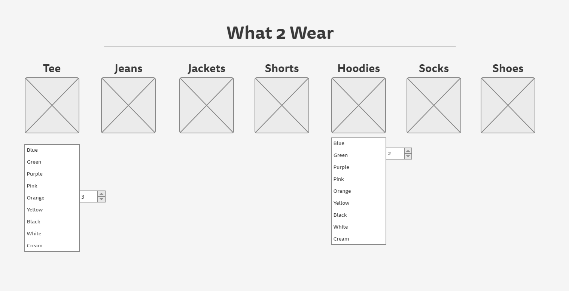The basic run down:

Simple design in which a user would enter what type of cloths they have like hoodies, tees, shirts etc. We may also allow for the option to select colours of the items for an extension onto our original project Idea. This would Keep track of when items need washing and have been worn.

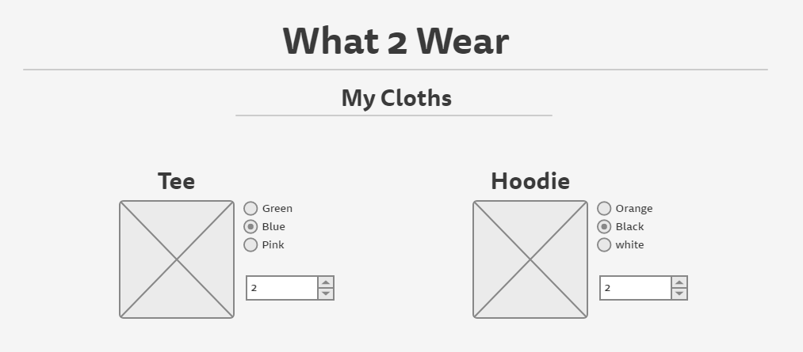

\*\*Optional design\*\*

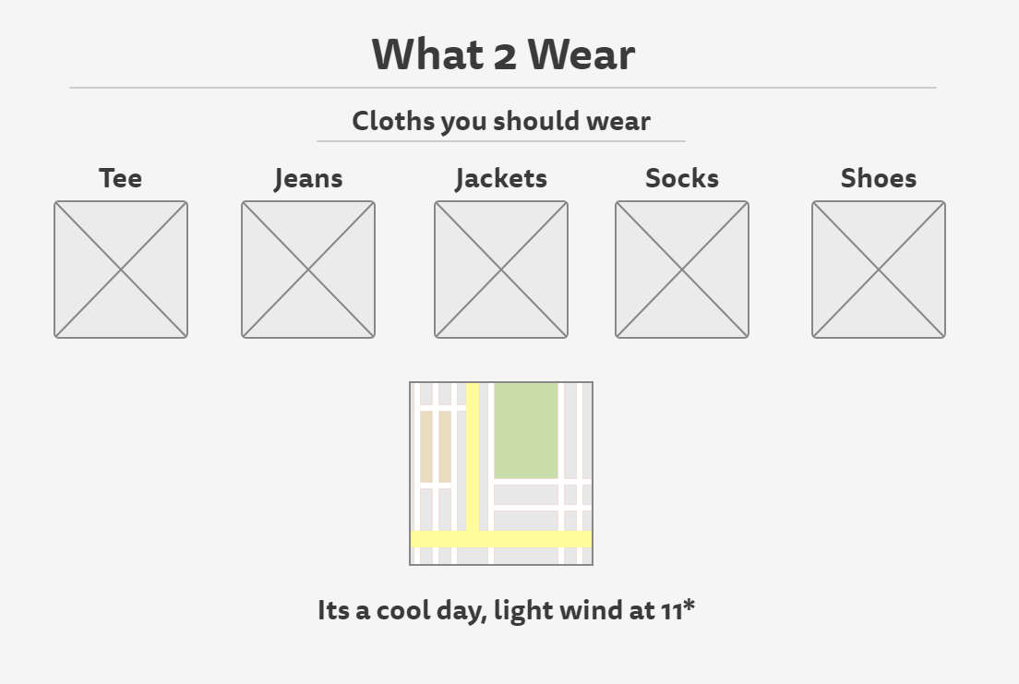

When the user would ask what they should wear the connected weather API would provide information on the temp, or the weather condition (e.g. raining) of the user’s location. From there the app would simply select specific cloths based on the weather (if it’s cold, take a jacket).

Further additions that could be made:

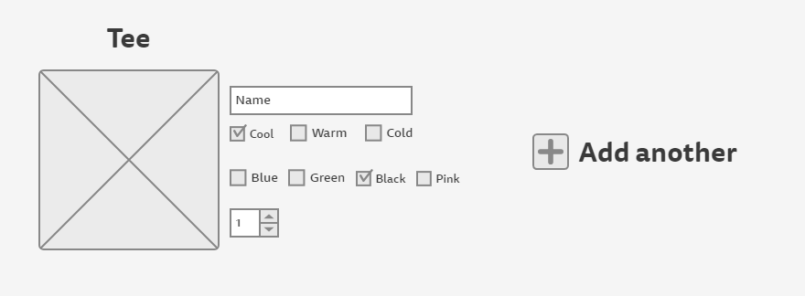

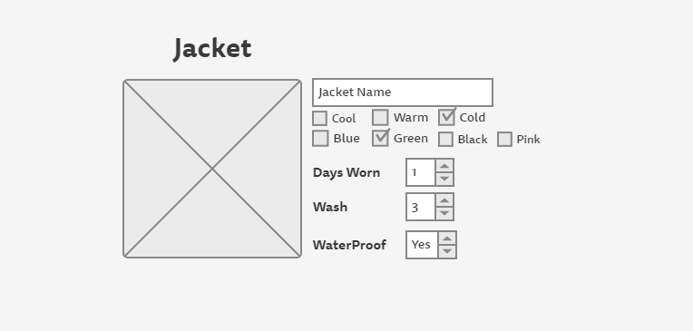Users would be able to add every unique item they own on the web app. The user would state what type of item it is e.g. T-Shirt / Jumper / Jacket / Jeans etc, they would also state what weather condition the specific item of clothing is suited to, e.g. hot, cool, cold. We would then use this to add further customisation to the selection of clothes we suggest to the user based off a given weather condition (If the clothing item is selected for cold weather, it will be added to a pool of clothes that would be suggested only once a certain temperature is reached).

Furthermore, the user will provide us with additional information such as if the item is waterproof, how many days they have worn the item and how often they wash the item (e.g. after wearing it twice…). The addition of telling us if the item is waterproof is just an additional option for us query against when selecting the item of clothing for a weather condition. However, the wash cycle and times worn will allow us to keep track of when the user has worn the item and needs washing. We will create a virtual washing basket to show the user the worn items and items in need of washing. Items in need of being washed will not be selected for the user to wear when the app selects the clothes for the day. from there the user will be able to input when a specific item has been washed, moving it back into the selection of available clothing.

Here is an example of how the basket could work:

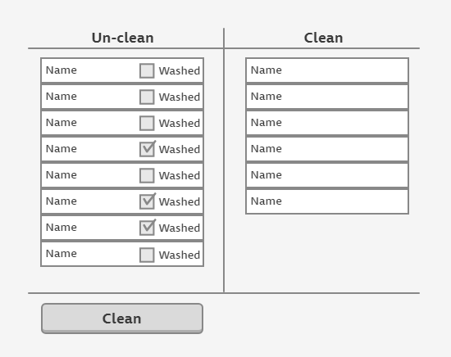

In addition to this, colour could be used to tell the user what items of clothing can be washed together and what items cannot.



Finally, the application could also allow the user to refresh the selection of clothes that have been shown to them. However, the app would need to tell if the clothes have been worn or not. For this we could implement an option for the user to state, “Yes is want to wear this” or “refresh the selection”. If the user refreshes, the clothes don’t get a day of wear added to them, if they choose the wear the clothes, the items would each have a day added onto the number of days they have worn the items.